**SUPERSTORE SALES REPORT**

1. **Introduction**

This document explains the development of a Sales Report for the Superstore's Sales Manager. The report leverages a database designed to track sales, profit, and return data, enabling the Sales Manager to gain valuable insights into company performance.

1. **Build database**

A database named "Superstore DB" was created using SQL Server to manage sales data. This database includes two primary tables:

* **superstore_orders**: Stores order details like row_id , order_id, order_date, ship_date, ship_mode, customer_id, customer_name, segment, country, city, state, postal_code, region, product_id, category, sub_category, product_name, sales, quantity, discount, profit
* **superstore_return**: Tracks order returns with fields like returned, order_id.

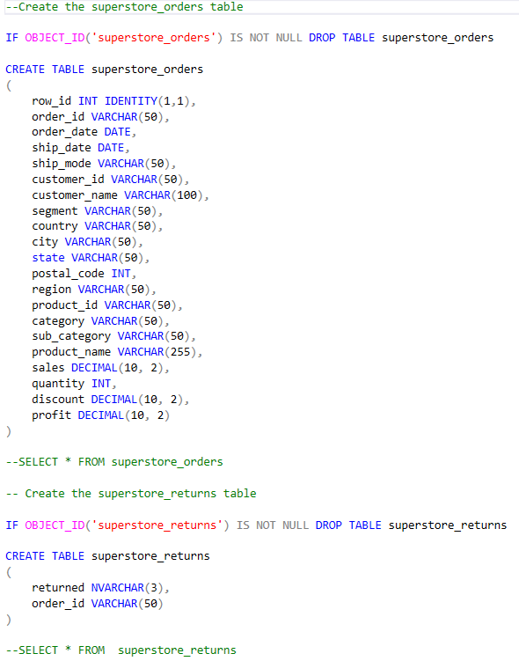

After carefully mapping the data fields, I imported the information from a CSV file to populate the newly created tables

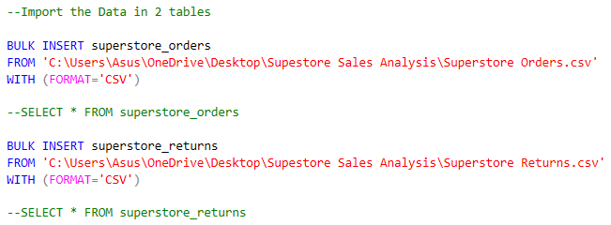

1. **Data Access and Automation**

* I created a view named "superstore_excel_input" to filter the data from the 'superstore_orders' and 'superstore_return' tables before importing them. This would ensure the data imported into Power BI is in the desired format for analysis.

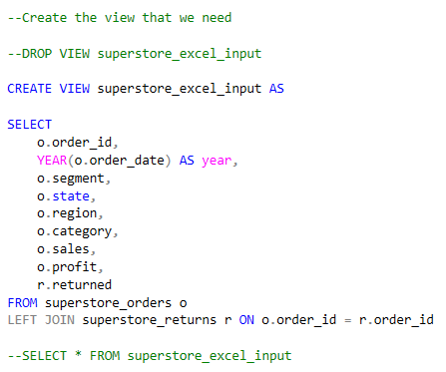

* To ensure data freshness, a stored procedure automates the process of replicating table structures and importing data from CSV files. This procedure includes error handling to address potential import issues.

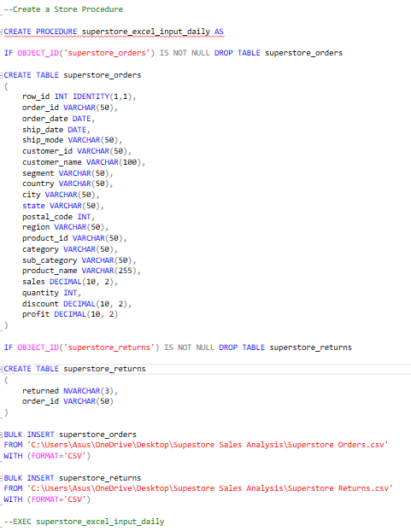

* A daily job is scheduled to automatically run the stored procedure at 7:00 AM, guaranteeing reports are updated whenever the CSV file is refreshed.

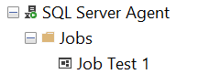

1. **Sales Report**

The Sales Report provides the Sales Manager with a comprehensive view of company performance through:

* Key Sales Metrics: Track overall sales trends, identify sales strengths by region/product/customer, analyze profitability, and monitor return rates.
* Data Visualization: Charts and graphs visually represent key metrics, making it easier to identify trends and patterns.
* Actionable Insights: The data-driven approach empowers the Sales Manager to develop targeted marketing campaigns, focus resources on high-performing products, and implement strategies to improve product quality or customer satisfaction (potentially leading to reduced returns).

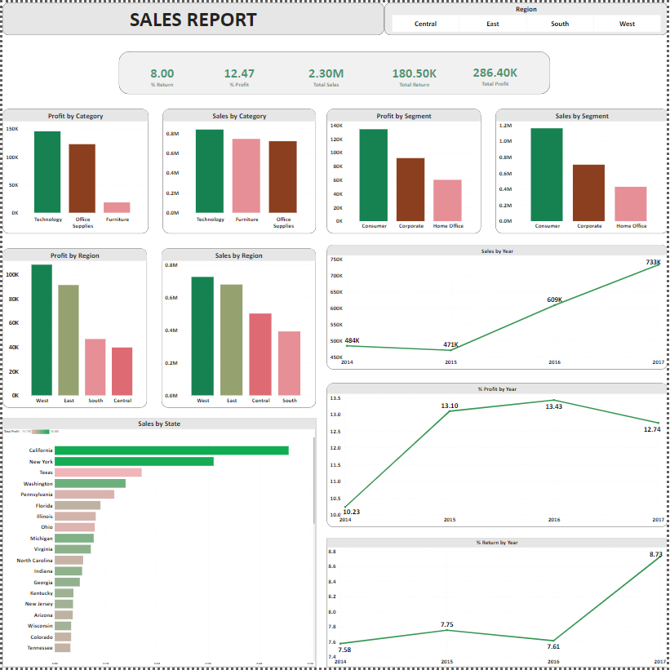**Sales Report**

**Link Report:** [**Sales Report**](https://app.powerbi.com/groups/me/reports/05cc9aa6-036e-4b4f-ad9e-87a5c57693d0?ctid=07acb355-56bc-489b-b98c-8fea440460e8&pbi_source=linkShare)